1. Demo access to HTTPS secured talent search

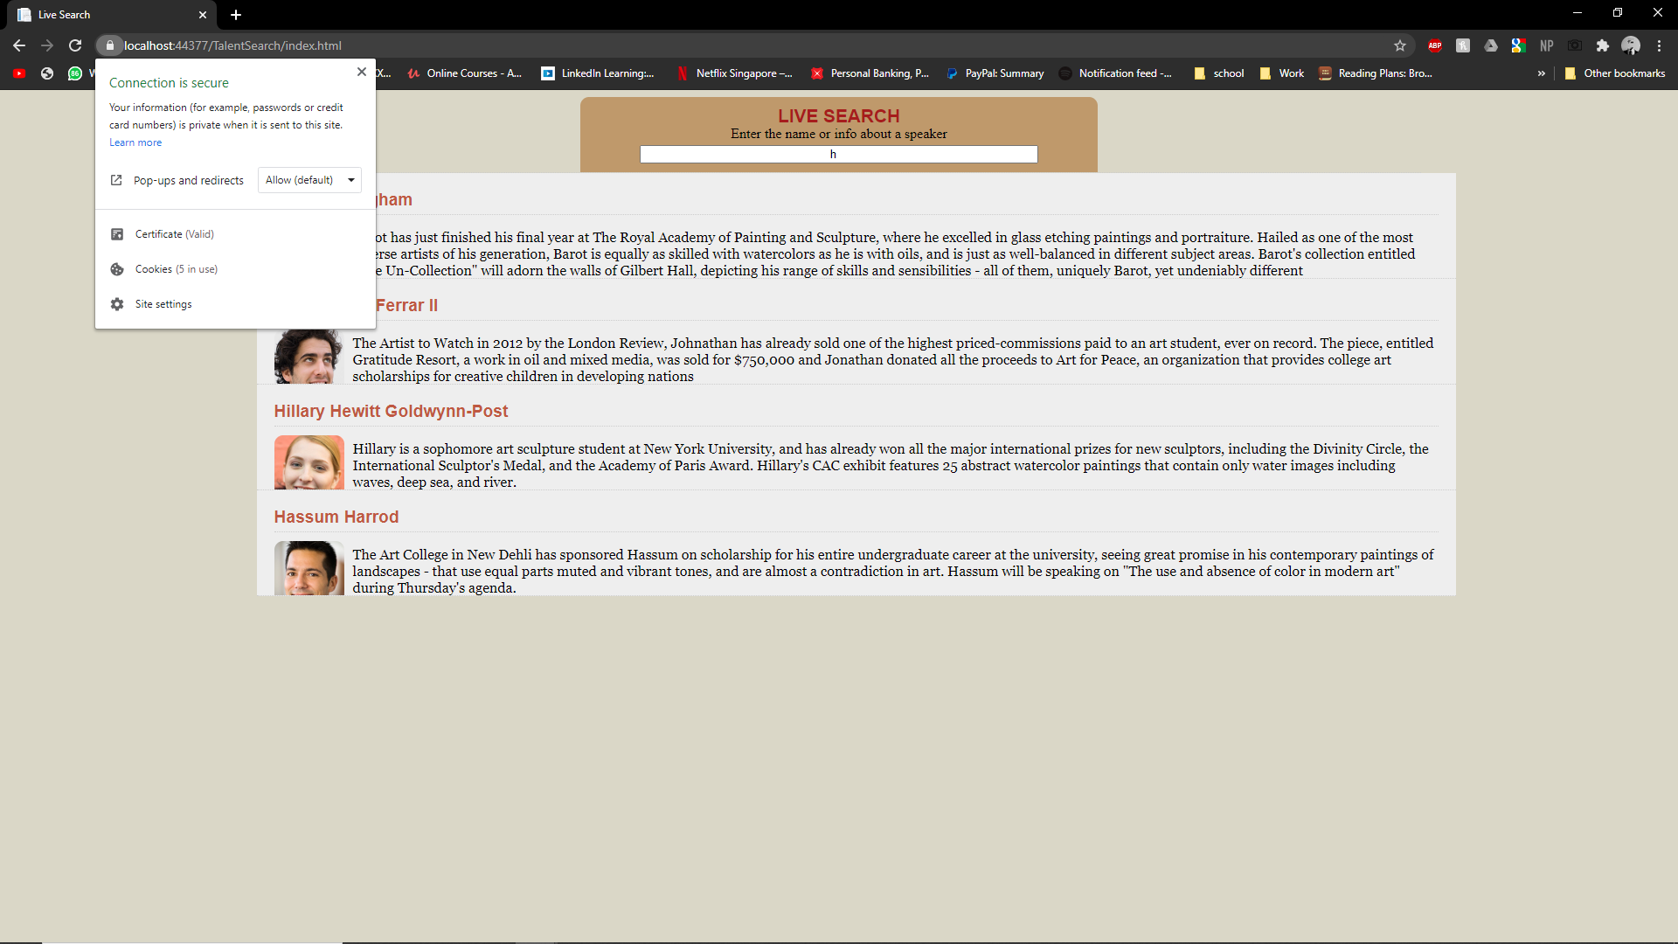

1. Demo if users try to access unsecured talents search users will be redirected to secured talent search.



1. Postman testing result

